Tec.Nano 2019

Exploring the effect of Mechanical Compressive Treatment in Electrical Conductivity of SU-8-based Carbon Structures

Saeed Beigi-Boroujenia, Alan Aguirre-Sotoa, Antonio Osamu Katagiri Tanakaa

aITESM MTY, Av. Eugenio Garza Sada Sur, Monterrey, 2501, N.L., Mexico

Abstract

In this study, the effects of physical treatment on electrical conductivity of SU-8 sheets were investigated. SU-8 sheets were fabricated through mechanical compressive treatment and subsequently stabilized under UV exposure and followed by pyrolization. The conductivity of samples was investigated by four-point-probe method. The extent of graphitization and crystallinity of microstructure were evaluated by XRD and Raman Spectroscopy. Although it was hypothesized that applying compressive force may change the molecular orientation and enhance the stacking of graphene layer, the results showed no significant changes.

© 2019 Elsevier Ltd. All rights reserved.

Peer-review under responsibility of the scientific committee of the International Conference on Nanotechnology Tec.Nano 2018.

*Keywords:* SU-8 photoresist; Electrical conductivity; Stress-induced graphitization

1. Introduction

Graphitic forms of carbon have attracted a great deal of attention in a wide variety of applications owning to their low reactivity, good electrical and thermal properties, stiffness, excellent optical transparency perpendicular to the transmitted light, and electrochemical stability [1–8]. In particular, the excellent electrical properties in graphitic carbon makes it valuable for several applications, such as sensors, batteries, supercapacitors, and transistors [9–11].

Carbon pyrolysis has been known as a widespread approach for fabricating graphitic carbon microstructures. In this method, different precursor materials are used at high temperature in an inert atmosphere or under vacuum for synthesis of graphitic structures [12]. SU-8, which is known as a negative high transparency UV photoresist, is one the best commercially available precursor materials. SU-8 contains eight epoxy moieties that can undergo cationic polymerization and produce a highly cross-linked matrix (Figure 1), which enable the fabrication of graphitic carbon structures through conventional processes such as photolithography and pyrolysis techniques [12–14].

Since graphitic materials often have a distribution of crystalline domains, their electrochemical behavior considerably depends on the microstructure. Recently, different chemical and physical methods have been applied to increase the graphitization and enhance the electrochemical properties [14–17]. In this regard, physical treatment has been considered due to being simple and cost effectiveness.

Ghazinejad et al. [17] investigated the effect of electro-mechanical aspects on increasing the graphitization and molecular alignment in a polymer precursor. In this regard, they used an electrospinning process in which an electrohydrodynamic force were applied to unwind and orient the molecular chains and after stabilization they pyrolyzed samples. The results showed a significant enhancement in structure and properties of pyrolytic carbons.

On the other hand, Cardenas-Benitez et al. [12] studied the pyrolysis-induced shrinkage of photocured SU-8 structures arisen from the volatilized material/degassing and surface area of the microstructures, where the structures shrank about 70% of their original size. The shrinkage and elongation of suspended SU-8 fibers during pyrolysis influences the resulting electrical properties [14]. Canton et al. [14] deposited SU-8 fibers in supporting SU-8 walls, as the walls shrink during pyrolysis strain forces elongate the fibers. Evidence states that the electrical conductivity increases when fibers are elongated/stretched with a decrease of their diameter [14].

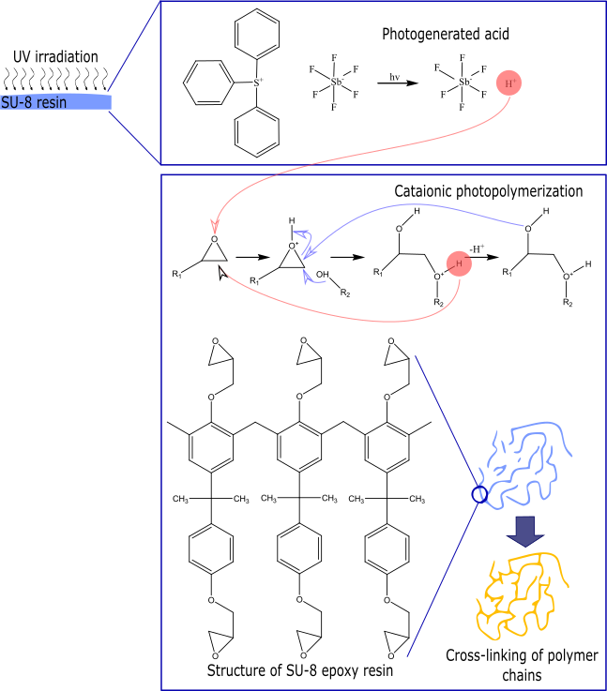

Fig. 1. Cationic photocrosslinking of SU-8 on exposure to UV light

Furthermore, literature suggest that the electrical conductivity of carbon electrodes is enhanced with the execution of pre-pyrolysis treatments, as the precursor polymer chains align within the fibers yielding carbon structures with enhanced quality and crystallinity [18,19]. Recent efforts [16,17,20] report carbon fibers with superior electrical conductivity, where the polymer chains are aligned with the aid of carbon nanotubes and hydro-electromechanical strain via electrospinning processes [21]. The aim of this paper is to evaluate the effect of mechanical compressive treatment on SU-8 sheets. The mechanical compressive treatment is a pre-pyrolysis processing that can work along with other techniques to further enhance the electrical conductivity of SU-8-based carbon structures

1. Materials and Methods

In regarding to investigate the effect of the mechanical compressive treatment, the compressed sample was fabricated as the following steps (Figure 2). The SU-8 2100 (MicroChem, USA) was casted and its solvent evaporated by increasing the hotplate temperature to 75 °C for 4h. In the following the pre-heated SU-8 sheet was compressed by applying a compressive force about 20KN for 30minutes. The compressed sample quickly underwent the UV exposure and subsequently pyrolyzed at 1000 °C under N2 atmosphere. The control sample was fabricated without applying the mechanical compressive force. X-ray diffraction (XRD) pattern for samples was recorded over a 2θ in the range of 5-55° using a (Model) equipped with the Cu Kα radiation source. The Raman studies was carried out using a Bruker Raman microscope spectrometer equipped with a 532 nm laser. The Raman maps and the averaged Raman spectra were collected across 5µm-5 µm areas of samples. The conductivity of samples was measured using a four-point-probe. In this method four probes are placed in contact with the sheet sample surface. The current is applied through the sample from the outer two probes and thereby the voltage drop is measured by the inner two probes [22]. In very thin samples, the resistivity is calculated using the following equation (1):



(1)

Where, V is the voltage, I is the applied current, and t is the thickness of the thin sample sheet.

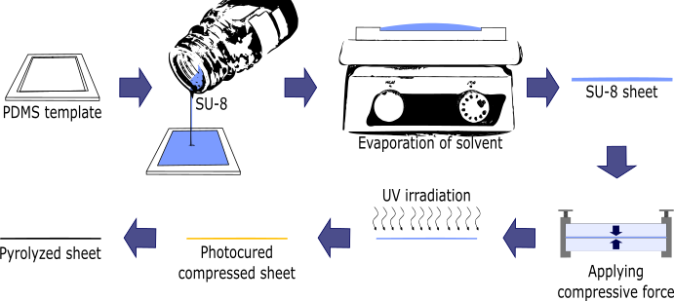

Fig. 2. Schematic diagram of the fabrication process for samples

1. Results and discussion

Conductivity measurement is known as a very efficient method regarding evaluation the extent of graphitization and thereby measuring the resistance. In this regards the conductivity of samples was measured using a four-point-probe. Figure 3 shows the average conductivity of samples and accordingly there is no significant differences between the conductivity of two samples. This result shows that the mechanical compressive treatment does not significantly affect the conductivity.

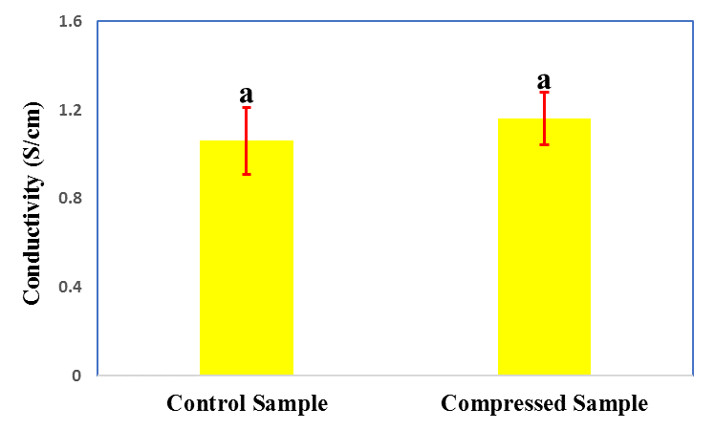

Fig. 3. Average conductivity of samples, according to the analysis of variances, the difference between quantities with similar superscripts(a) is not significant (p > 0.05).

The uniformity of graphitization microstructures can be evaluated by Raman Spectroscopy. Figure 4 shows the average Raman spectra of different samples. There are two characteristic peaks at 1367 and 1606 cm-1 which respectively assigned with D and G. The G peak arises from the stretching motion of the sp2-hybridized carbon-carbon bond in graphitic materials and D peak corresponds to the disorder structure. In this regard, the intensity ration of D peak to G peak is used for evaluation the quality of graphitization. Hence, the higher the D to G ratio is related to the lower alignment of graphitic planes and thereby lower degree of graphitization in the carbon structure [23]. As it can be seen in Figure 4, the intensity of peaks is the same and it means that the mechanical compressive treatment does not change the graphitization microstructure. Furthermore, the mapping Raman Spectroscopy is depicted in Figure and shows the uniform mapping for two samples. This uniformity corresponds to the uniform graphitization microstructures of samples.

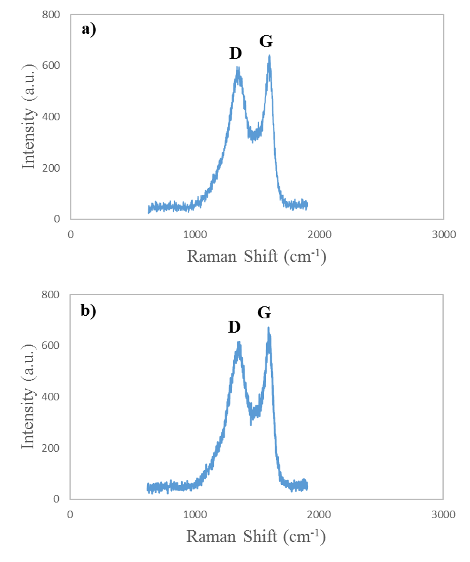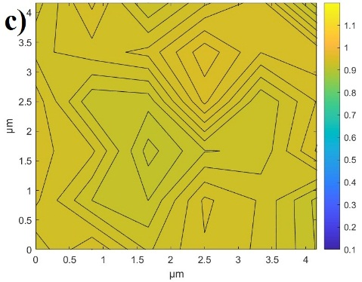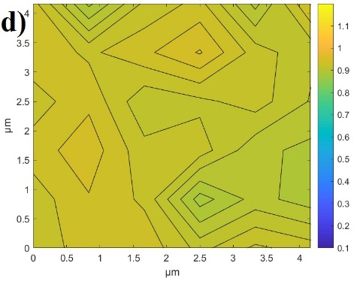

Figure 4: Average Raman spectrum of a) Control Sample and b) Compressed Sample. Mapping of Raman spectroscopy of c) Control Sample and d) Compressed Sample.

We also carried out XRD analysis to evaluate the crystalline microstructure. The results are shown in Figure 5 and two broad diffraction peaks can be observed in both the samples, in 22° and 55°. The broad band at 22° and 55 are related to (002) plane and (100) plane respectively [24]. The broadness of these peaks imply the poor stacking of graphene layers in (002) and (100) plane.

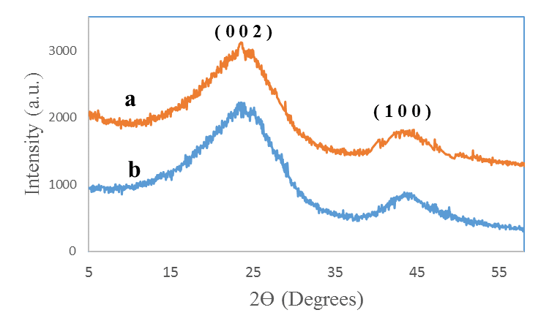

Figure 5: X-Ray diffraction pattern for a) Control Sample and b) Compressed Sample

# Nomenclature

PDMS Polydimethylsiloxane

UV Ultraviolet

References

[1] R.L. McCreery, Advanced Carbon Electrode Materials for Molecular Electrochemistry, Chem. Rev. 108 (2008) 2646–2687. https://doi.org/10.1021/cr068076m.

[2] A.K. Geim, Random Walk to Graphene (Nobel Lecture), Angew. Chemie Int. Ed. 50 (2011) 6966–6985. https://doi.org/10.1002/anie.201101174.

[3] M.J. Allen, V.C. Tung, R.B. Kaner, Honeycomb Carbon: A Review of Graphene, Chem. Rev. 110 (2010) 132–145. https://doi.org/10.1021/cr900070d.

[4] Y. Zhu, S. Murali, W. Cai, X. Li, J.W. Suk, J.R. Potts, R.S. Ruoff, Graphene and Graphene Oxide: Synthesis, Properties, and Applications, Adv. Mater. 22 (2010) 3906–3924. https://doi.org/10.1002/adma.201001068.

[5] M.. Katsnelson, A.. Geim, Electron scattering on microscopic corrugations in graphene, Philos. Trans. R. Soc. A Math. Phys. Eng. Sci. 366 (2008) 195–204. https://doi.org/10.1098/rsta.2007.2157.

[6] D. Li, R.B. Kaner, MATERIALS SCIENCE: Graphene-Based Materials, Science (80-. ). 320 (2008) 1170–1171. https://doi.org/10.1126/science.1158180.

[7] A.K. Geim, K.S. Novoselov, The rise of graphene, Nat. Mater. 6 (2007) 183–191. https://doi.org/10.1038/nmat1849.

[8] A.K. Geim, Graphene: Status and Prospects, Science (80-. ). 324 (2009) 1530–1534. https://doi.org/10.1126/science.1158877.

[9] H.C. Schniepp, J.-L. Li, M.J. McAllister, H. Sai, M. Herrera-Alonso, D.H. Adamson, R.K. Prud’homme, R. Car, D.A. Saville, I.A. Aksay, Functionalized Single Graphene Sheets Derived from Splitting Graphite Oxide, J. Phys. Chem. B. 110 (2006) 8535–8539. https://doi.org/10.1021/jp060936f.

[10] H.C. Schniepp, K.N. Kudin, J.-L. Li, R.K. Prud’homme, R. Car, D.A. Saville, I.A. Aksay, Bending Properties of Single Functionalized Graphene Sheets Probed by Atomic Force Microscopy, ACS Nano. 2 (2008) 2577–2584. https://doi.org/10.1021/nn800457s.

[11] M.F. El-Kady, V. Strong, S. Dubin, R.B. Kaner, Laser Scribing of High-Performance and Flexible Graphene-Based Electrochemical Capacitors, Science (80-. ). 335 (2012) 1326–1330. https://doi.org/10.1126/science.1216744.

[12] B. Cardenas-Benitez, C. Eschenbaum, D. Mager, J.G. Korvink, M.J. Madou, U. Lemmer, I. De Leon, S.O. Martinez-Chapa, Pyrolysis-induced shrinking of three-dimensional structures fabricated by two-photon polymerization: experiment and theoretical model, Microsystems Nanoeng. 5 (2019). https://doi.org/10.1038/s41378-019-0079-9.

[13] B.Y. Park, L. Taherabadi, C. Wang, J. Zoval, M.J. Madou, Electrical Properties and Shrinkage of Carbonized Photoresist Films and the Implications for Carbon Microelectromechanical Systems Devices in Conductive Media, J. Electrochem. Soc. 152 (2005) J136. https://doi.org/10.1149/1.2116707.

[14] G. Canton, T. Do, L. Kulinsky, M. Madou, Improved conductivity of suspended carbon fibers through integration of C-MEMS and Electro-Mechanical Spinning technologies, Carbon N. Y. 71 (2014) 338–342. https://doi.org/10.1016/j.carbon.2014.01.009.

[15] N. Liu, K. Kim, H.Y. Jeong, P.C. Hsu, Y. Cui, Z. Bao, Effect of Chemical Structure on Polymer-Templated Growth of Graphitic Nanoribbons, ACS Nano. 9 (2015) 9043–9049. https://doi.org/10.1021/acsnano.5b03134.

[16] A. Allaoui, S.V. Hoa, M.D. Pugh, The electronic transport properties and microstructure of carbon nanofiber/epoxy composites, Compos. Sci. Technol. 68 (2008) 410–416. https://doi.org/10.1016/j.compscitech.2007.06.028.

[17] M. Ghazinejad, S. Holmberg, O. Pilloni, L. Oropeza-Ramos, M. Madou, Graphitizing Non-graphitizable Carbons by Stress-induced Routes, Sci. Rep. 7 (2017) 16551. https://doi.org/10.1038/s41598-017-16424-z.

[18] T. Maitra, S. Sharma, A. Srivastava, Y.K. Cho, M. Madou, A. Sharma, Improved graphitization and electrical conductivity of suspended carbon nanofibers derived from carbon nanotube/polyacrylonitrile composites by directed electrospinning, Carbon N. Y. 50 (2012) 1753–1761. https://doi.org/10.1016/j.carbon.2011.12.021.

[19] D. Mattia, M.P. Rossi, B.M. Kim, G. Korneva, H.H. Bau, Y. Gogotsi, Effect of Graphitization on the Wettability and Electrical Conductivity of CVD-Carbon Nanotubes and Films, J. Phys. Chem. B. 110 (2006) 9850–9855. https://doi.org/10.1021/jp061138s.

[20] S. Holmberg, M. Ghazinejad, E. Cho, D. George, B. Pollack, A. Perebikovsky, R. Ragan, M. Madou, Stress-activated pyrolytic carbon nanofibers for electrochemical platforms, Electrochim. Acta. 290 (2018) 639–648. https://doi.org/10.1016/j.electacta.2018.09.013.

[21] M. Yoonessi, J.R. Gaier, M. Sahimi, T.L. Daulton, R.B. Kaner, M.A. Meador, Fabrication of Graphene–Polyimide Nanocomposites with Superior Electrical Conductivity, ACS Appl. Mater. Interfaces. 9 (2017) 43230–43238. https://doi.org/10.1021/acsami.7b12104.

[22] B. Xue, Y. Zou, Y. Yang, A photochemical approach for preparing graphene and fabrication of SU-8/graphene composite conductive micropatterns, Mater. Des. 132 (2017) 505–511. https://doi.org/10.1016/j.matdes.2017.07.034.

[23] Y.M. Hassan, C. Caviglia, S. Hemanth, D.M.A. Mackenzie, T.S. Alstrøm, D.H. Petersen, S.S. Keller, High temperature SU-8 pyrolysis for fabrication of carbon electrodes, J. Anal. Appl. Pyrolysis. 125 (2017) 91–99. https://doi.org/10.1016/j.jaap.2017.04.015.

[24] S. Mamidi, M. Kakunuri, C.S. Sharma, Fabrication of SU-8 Derived Three-Dimensional Carbon Microelectrodes as High Capacity Anodes for Lithium-Ion Batteries, ECS Trans. 85 (2018) 21–27. https://doi.org/10.1149/08501.0021ecst.